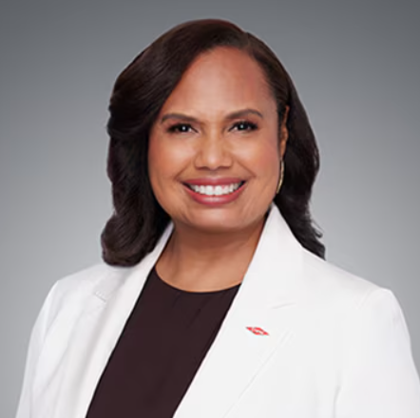++Leadership Brief
Karen Carter, CEO Dow: The Future is Here
Recognize Dow’s newly appointed CEO, Karen Carter, who began her high-profile leadership tenure on Wednesday July 1st. Carter's leadership reflects the growing importance of executives who can successfully navigate the intersection of global business, sustainability, and strategic growth. Throughout her career at Dow, she’s been known for her ability to lead complex organizations, build high-performing teams, and advance initiatives that strengthen both business performance and stakeholder relationships. As global markets continue to evolve, Carter's approach offers valuable lessons on leading change while maintaining a clear strategic vision for growth and innovation.
The global industrial landscape is shifting, and its deep impact is being felt by the global financial ecosystem. This reality has required Dow to look to Karen Carter to navigate the complexities of the current economic environment. Karen’s 30-year history and commitment to Dow have allowed her to capitalize on the skills she’s mastered while at Dow.
As Chief Operating Officer, Karen Carter was known to have focused on customer relationships and commercializing new products. Having also served as President of Dow’s largest segment, Packaging and Specialty Plastics, that experience has positioned her to deliver high value for shareholders and customers as emerging markets look to make vital gains.
Carter’s leadership represents a principle that values close customer relationships and a disciplined approach to executing initiatives that require a long-term collective focus. Stakeholder confidence is critical to Dow’s expansion across multiple sectors. Especially when growing populations require partnerships that need stable water, food, and healthcare infrastructure to support rapid urbanization. Carter’s approach will allow Dow to realize win-win opportunities and build overall economic capacity for all parties invested in Dow’s future.
As Dow pursues margin stability and long-term growth, Karen Carter has a unique opportunity to expand the company's global footprint and cement her reputation among the world's most influential multinational business leaders.

